***GUIDELINES FOR ABSTRACTS***

#### GUIDELINES FOR EXTENDED ABSTRACTS FOR ICFMD2024 (14pt ARIAL BOLD)

A.K. Arof Times New Roman 12pt;

Centre for Ionics Universiti Malaya, Department of Physics,

Universiti Malaya, 50603 Kuala Lumpur, Malaysia

Times New Roman 12pt

*corresponding author: XXXXX@yahoo.com Times New Roman Italic 12pt*

Our work was pioneering in the field of advanced materials. Text in Times New Roman 12pt. As pointed out by Poulain et al1 future belongs to photonics science. This statement was largely disputed by other authors2-3.



E=mc2 : this can be inserted in the text. E=mc2 : this can be inserted in the text. E=mc2 : this can be inserted in the text. E=mc2 : this can be inserted in the text. E=mc2 : this can be inserted in the text. E=mc2 : this can be inserted in the text. Text in Times New Roman 12pt. E=mc2 : this can be inserted in the text. E=mc2 : this can be inserted in the text. E=mc2 : this can be inserted in the text. 1 page only!

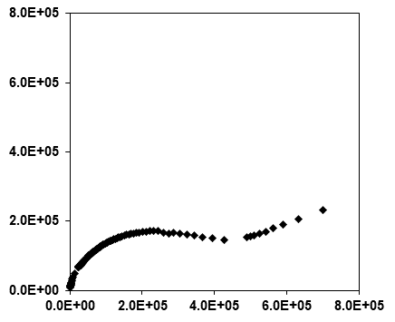

Zr

Zr

Fig.1. Graphs and drawings should be centered. Text in Times New Roman 12pt..

1. A. B. Snowy and P. Perdure, Photonics future, 15, (2005)461

2. F. Krol, G. Laisy and P. Wilk, Future science, 12, (2003)355

3. G. Magura, Electronics news, 11, 251(2005) Text in Times New Roman 12pt.