ABSTRACT SUBMISSION GUIDELINES FOR BIOMED-APOSM 2024
First Author^{1,2}, Second Author², Third Author² and Last Author ^{1,2}
¹ Department, University / Institute, City, Malaysia.
² Department, University / Institute, City, Malaysia.
Email: corresponding@utm.my

INTRODUCTION
All abstracts must be submitted using word template via the abstract submission system of the conference website. All abstracts must be submitted as WORD files. Heading and content of the abstract is structured into following sections: INTRODUCTION, METHODS, RESULTS AND DISCUSSION, CONCLUSION, ACKNOWLEDGEMENT AND REFERENCES.

METHODS
The abstract should be one A4 size page (210 x 297 mm) in the portrait orientation, with two columns of text, justified. The top margin should be 20 mm, while left, right and bottom margins should be 15 mm. Type font is Times New Roman (TNR) 11 pt, except for the figure/table captions, which should be in size 9 pt. This template is used to format your paper and style the text. The title (TNR, 11 pt, bold caps), authors, and author affiliations (TNR, 10 pt) should be centered across the top of the page. Use numerical superscripts to distinguish authors who are from different institutions. An email address of the corresponding author must be included (TNR, italic, 9 pt).
Abstract submission must be in one of the different tracks as follows,
- Cell and Molecular Biomechanics
- Fluid Biomechnics
- Soft Tissue Biomechanics
- Hard Tissue Biomechanics
- Human Movement and Robotic
- Sports Biomechanics
- Biomechanics in Injury and Rehabilitation
- Biomechanics in Nature
- BioMEMS and Biomaterial
- Computational Biomechanics
- Tissue and Organ Engineering
- Emerging and Multidisciplinary Biomechanics

RESULTS AND DISCUSSION
A maximum of one table and graph or image each can be included within the document and should be placed immediately after a paragraph and should be referenced parenthetically in the text (Figure 1 or Table 1). Captions should be placed below each figure and above each table. Tables may extend across two columns when needed, in which case they must be placed at the bottom of the page (Table 1). Use numbers in square brackets [1,2] to cite references within the text and format references at the end of the abstract as shown on this page.

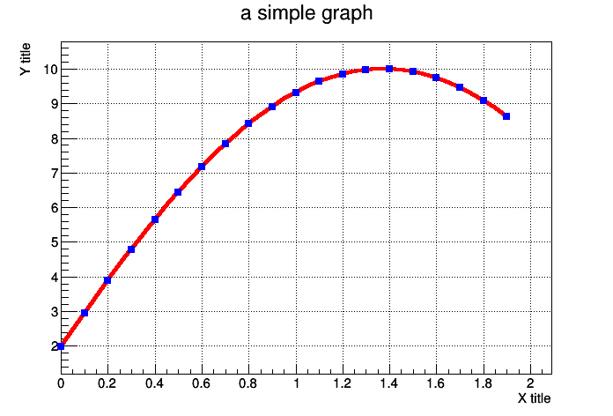
Figure 1 A graph or a picture/image.

CONCLUSION
Abstract will be reviewed blindly. The reviewers will judge the abstracts according to the scientific or clinical value, relevance to biomechanics, suitability to aims, conclusions confirmed by objective results, objectivity of statement, description of methods used, ethics, standard of English and overall impression.

ACKNOWLEDGEMENT
Acknowledgments are optional and may specify research funding and resources including organisation name and reference numbers (if applicable).

REFERENCES
[1] Michael J et al. J Biomed 105: 115-125, 2023.
[2] Wee LK et al. J Biomed 18: 56-62, 2021.
Table 1: Tables that extend across both columns should be placed at the bottom of the abstract.
 | Subjects A | Subjects B | Effect size | p-value
Variable 1 (Units) | 45.1 ± 0.2 | 56.2 ± 0.2 | 0.94 | p = 0.02
Variable 2 (Units) | 22.5 ± 0.6 | 37.1 ± 1.8 | 0.86 | p = 0.015

