26th Regional Symposium of Chemical Engineering  Kuala Lumpur, Oct 30-31, 2019 | RSCE2019

Group - local participant:

- Conference Payment

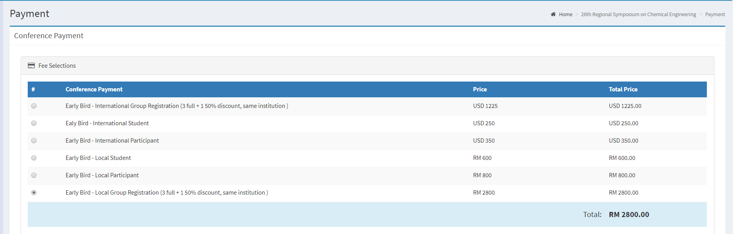

- Additional Payment

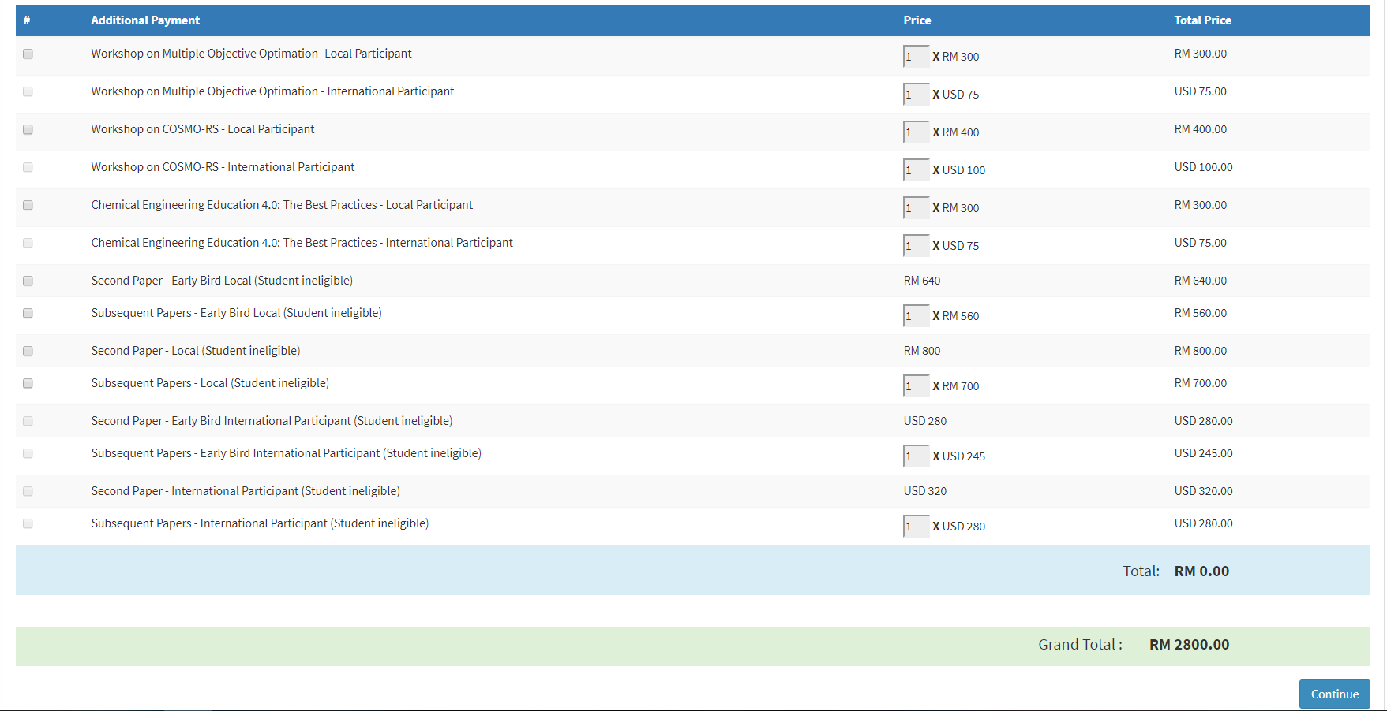
You are getting Group discounts for 4 participants. Total payment due is RM2800.

