26th Regional Symposium of Chemical Engineering  Kuala Lumpur, Oct 30-31, 2019 | RSCE2019

Multiple papers local participant (5 papers example):

- Conference Payment

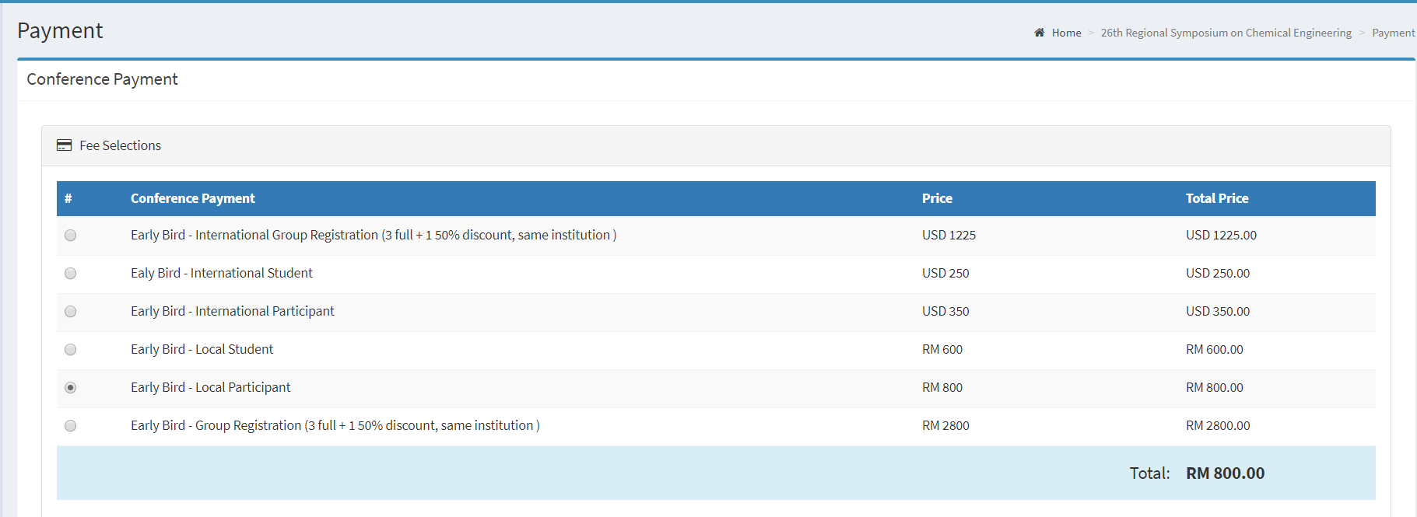

- Additional Payment

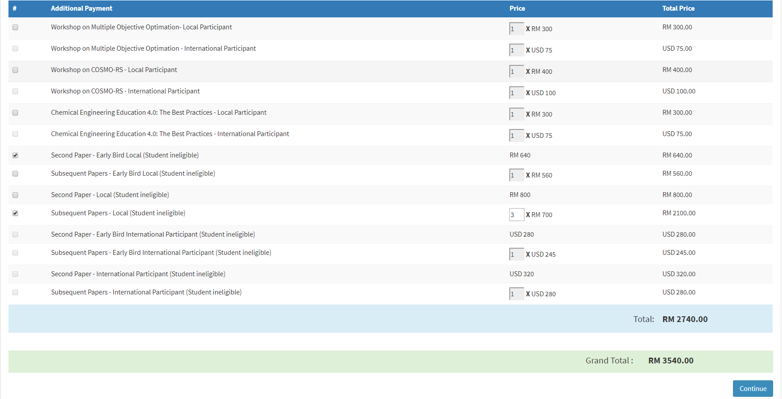
Five papers submitted. There are discounts for second paper onwards. Total payment due is RM3,540.

