26th Regional Symposium of Chemical Engineering  Kuala Lumpur, Oct 30-31, 2019 | RSCE2019

Single international participant with Pre-Conference Workshop:

- Conference Payment

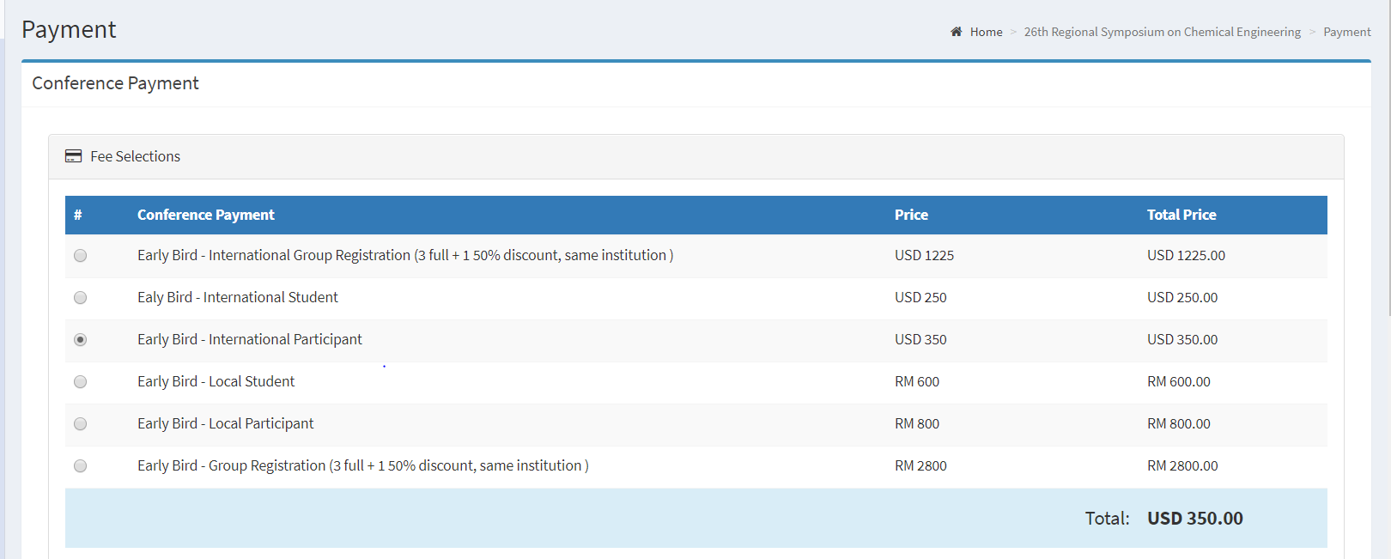

- Additional Payment

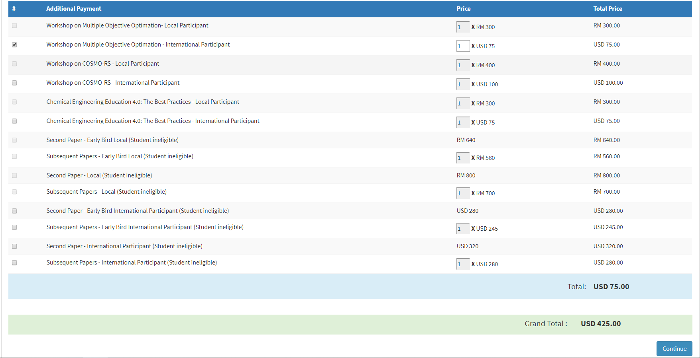
Single registration for local participant. Additional payment for one workshop of USD75 is added. Total payment due is USD425.

