26th Regional Symposium of Chemical Engineering  Kuala Lumpur, Oct 30-31, 2019 | RSCE2019

Single international participant:

- Conference Payment

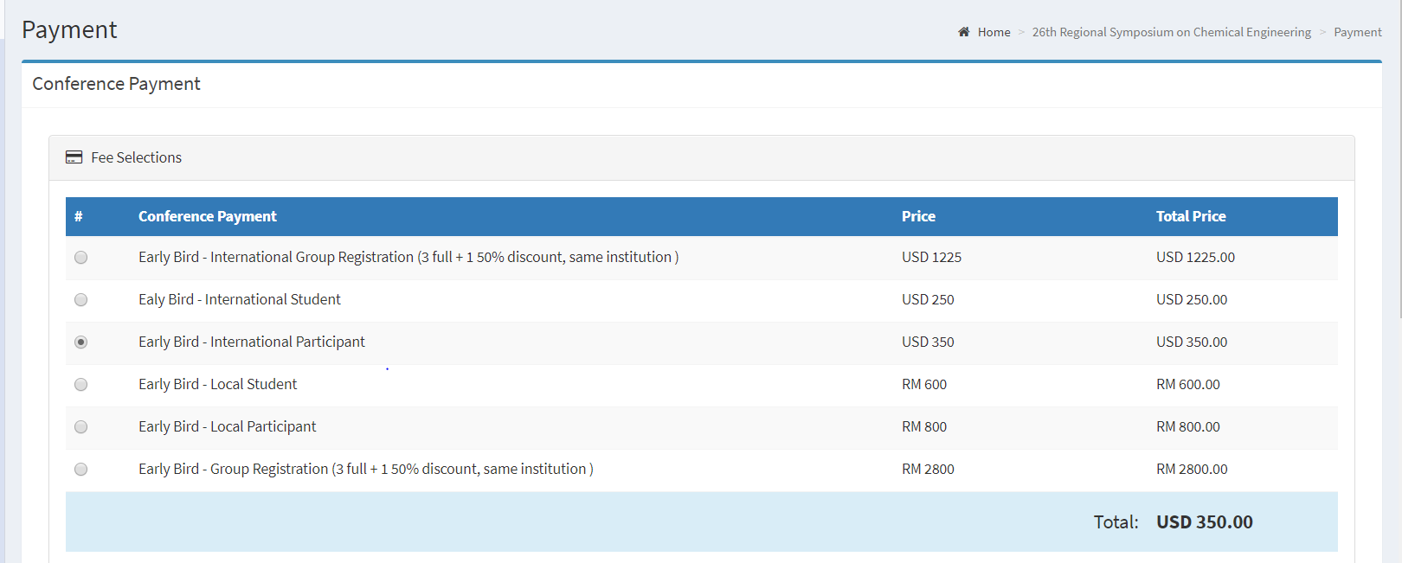

- Additional Payment

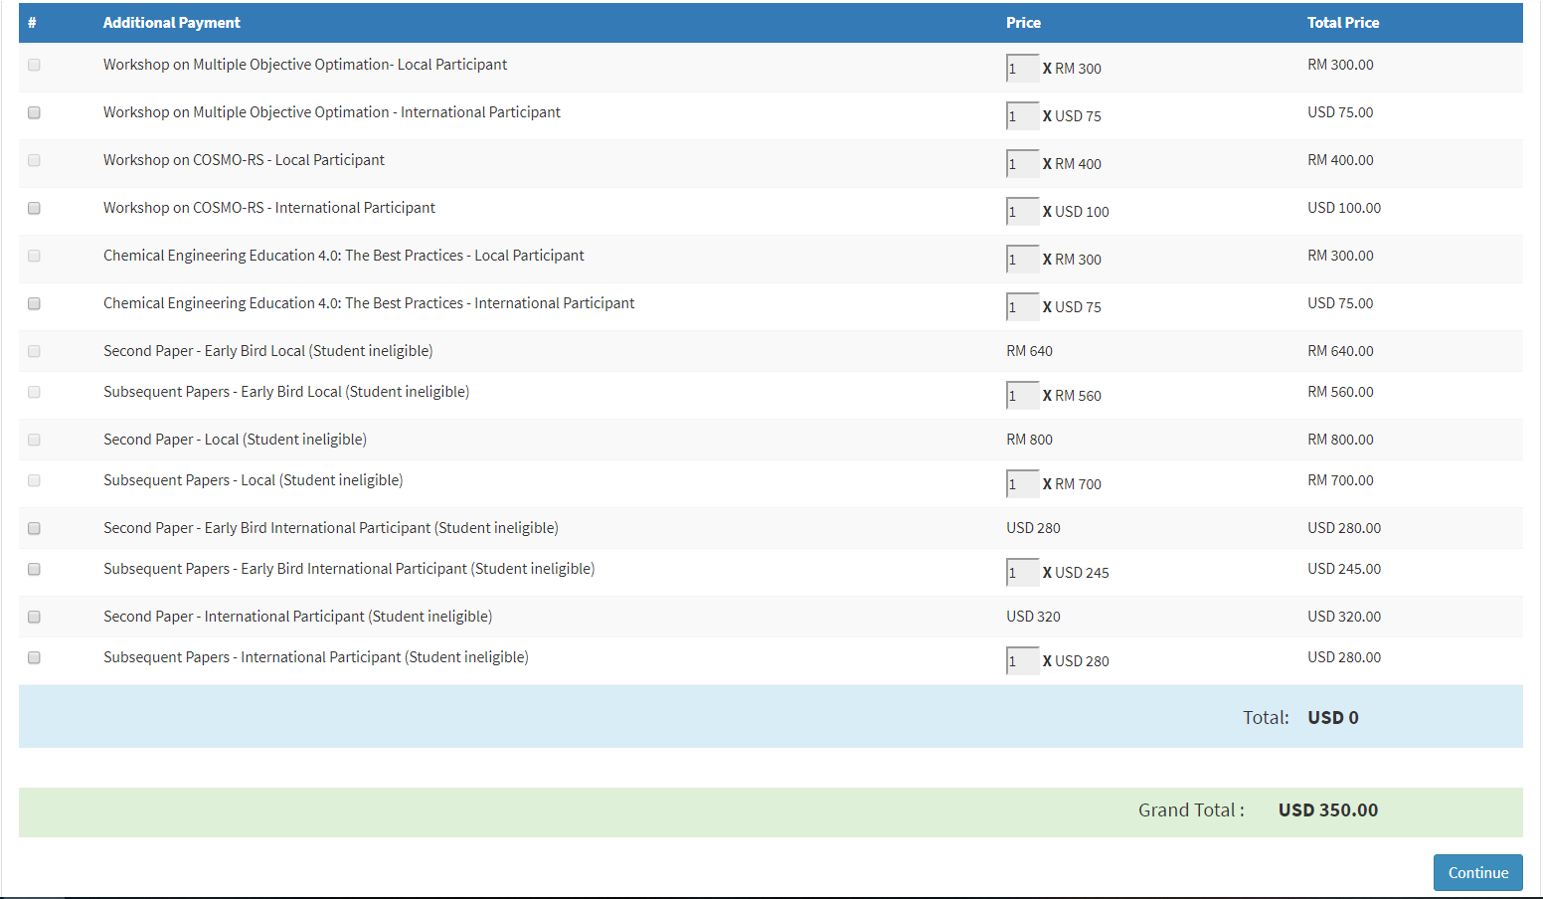
Single registration for international participant. No additional payment. Total payment due is USD350.

