26th Regional Symposium of Chemical Engineering  Kuala Lumpur, Oct 30-31, 2019 | RSCE2019

Pre-Conference Workshop only:

- Conference Payment

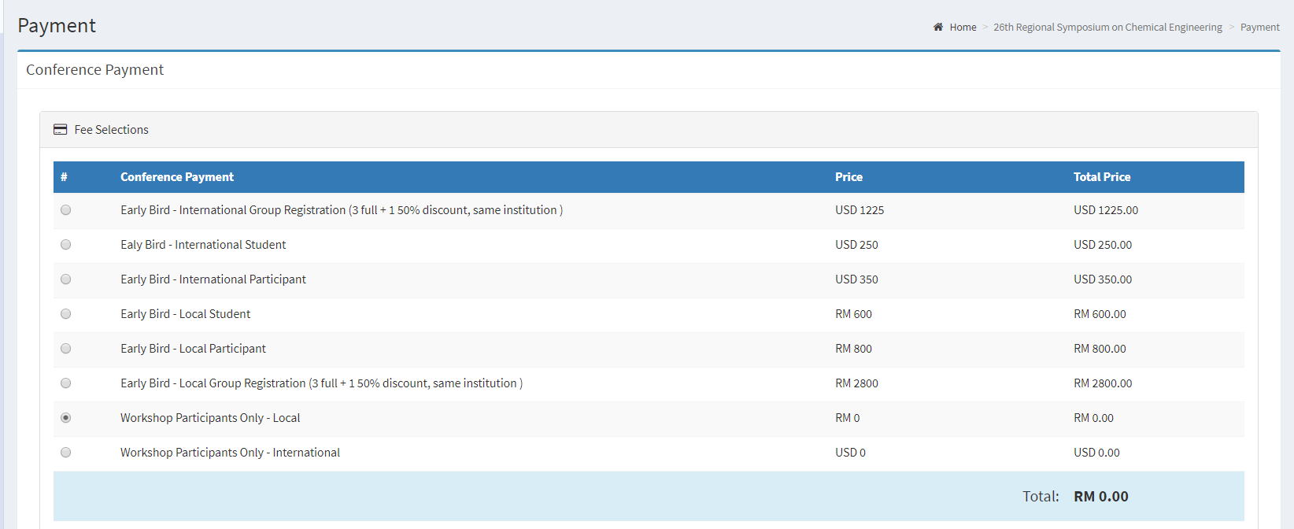

- Additional Payment
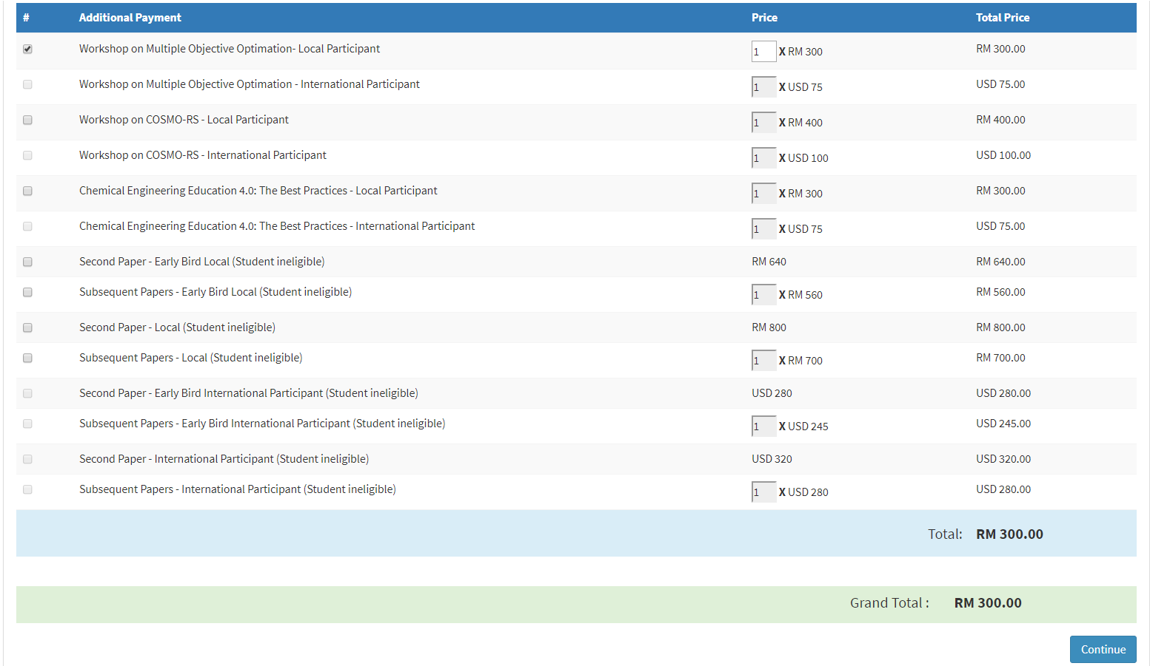
You are attending the workshop only. Additional payment of RM300 for one workshop. Total payment due is RM300.

