26th Regional Symposium of Chemical Engineering  Kuala Lumpur, Oct 30-31, 2019 | RSCE2019

Single local participant with Pre-Conference Workshop:

- Conference Payment

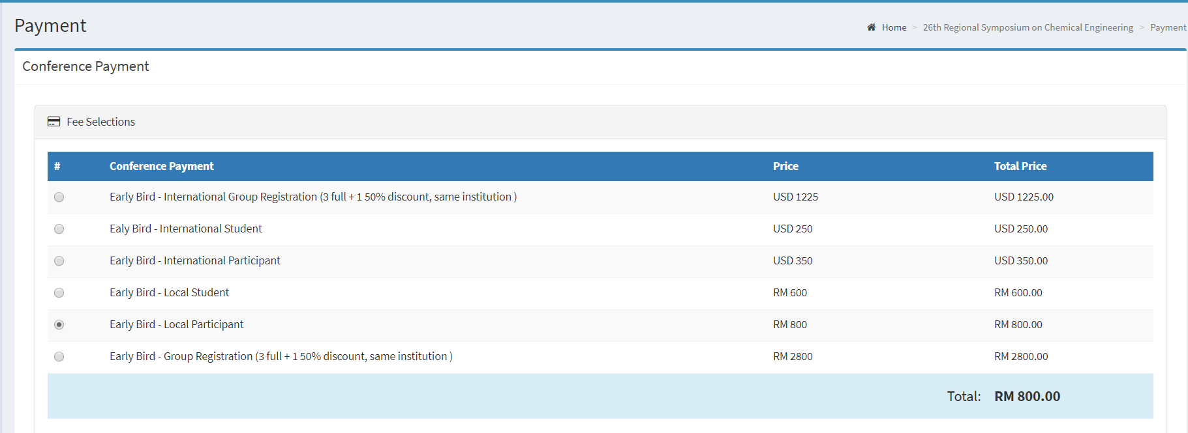

- Additional Payment

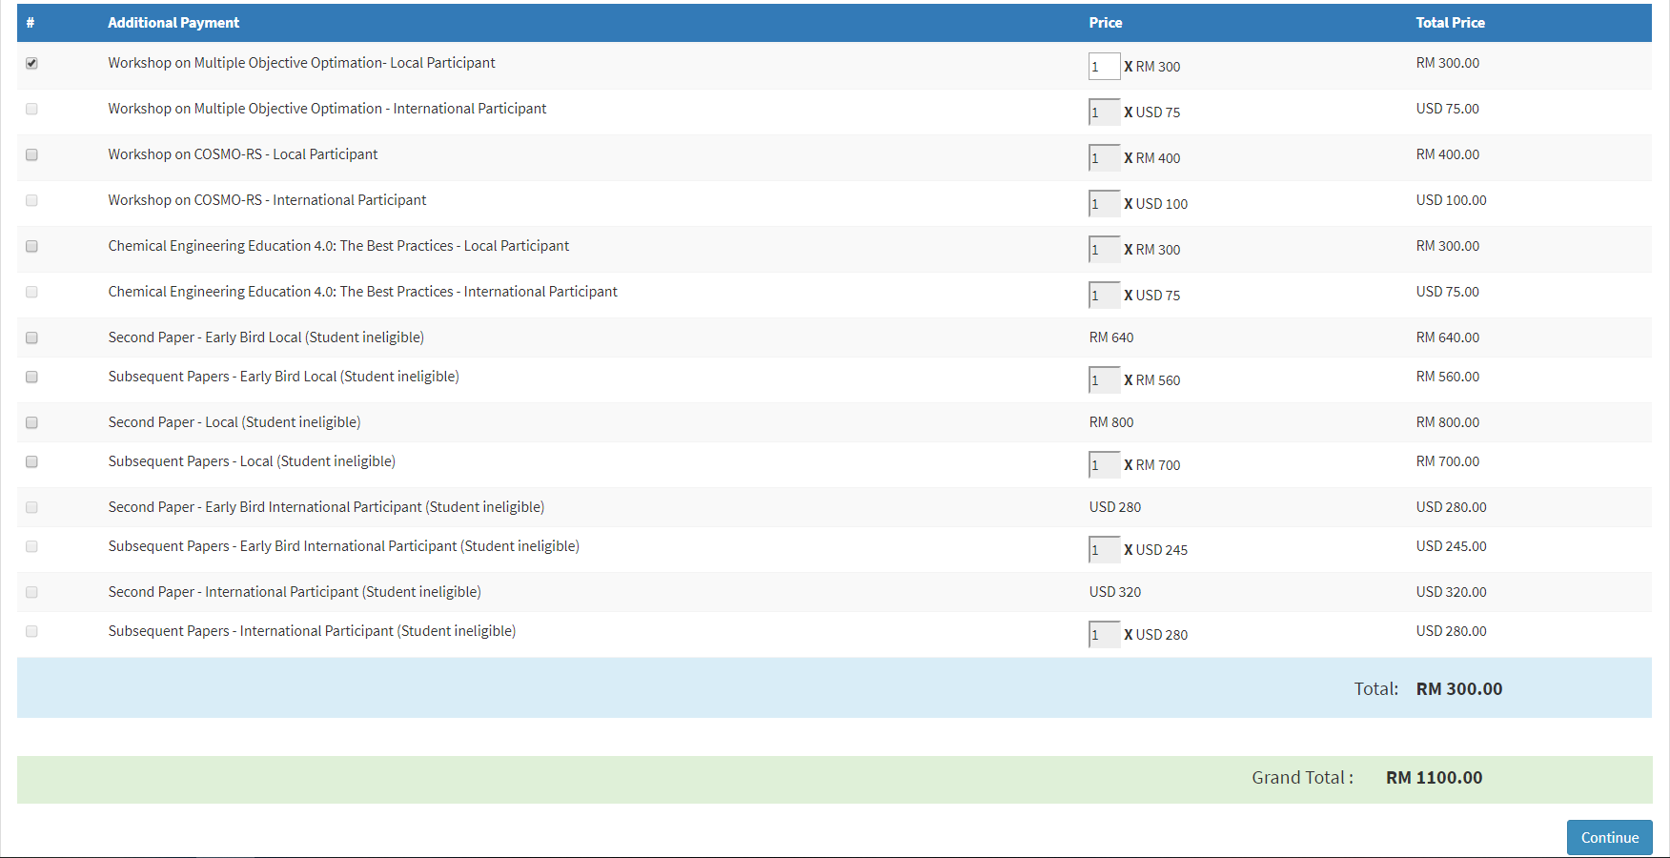

Single registration for local participant. Additional payment for one workshop of RM300 is added. Total payment due is RM1100.

