26th Regional Symposium of Chemical Engineering  Kuala Lumpur, Oct 30-31, 2019 | RSCE2019

Single local participant:

- Conference Payment

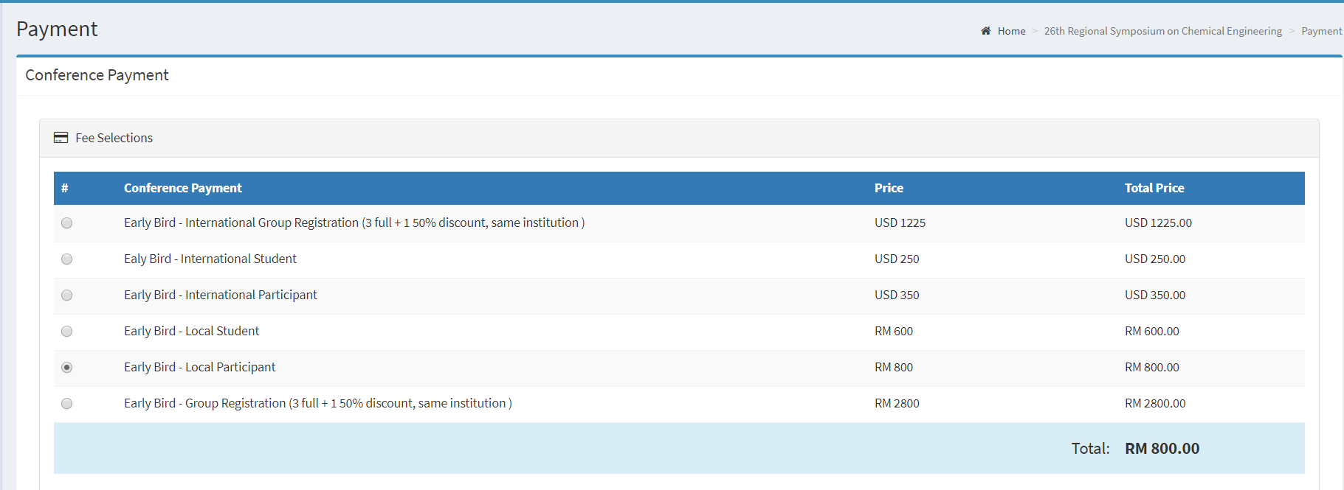

- Additional Payment

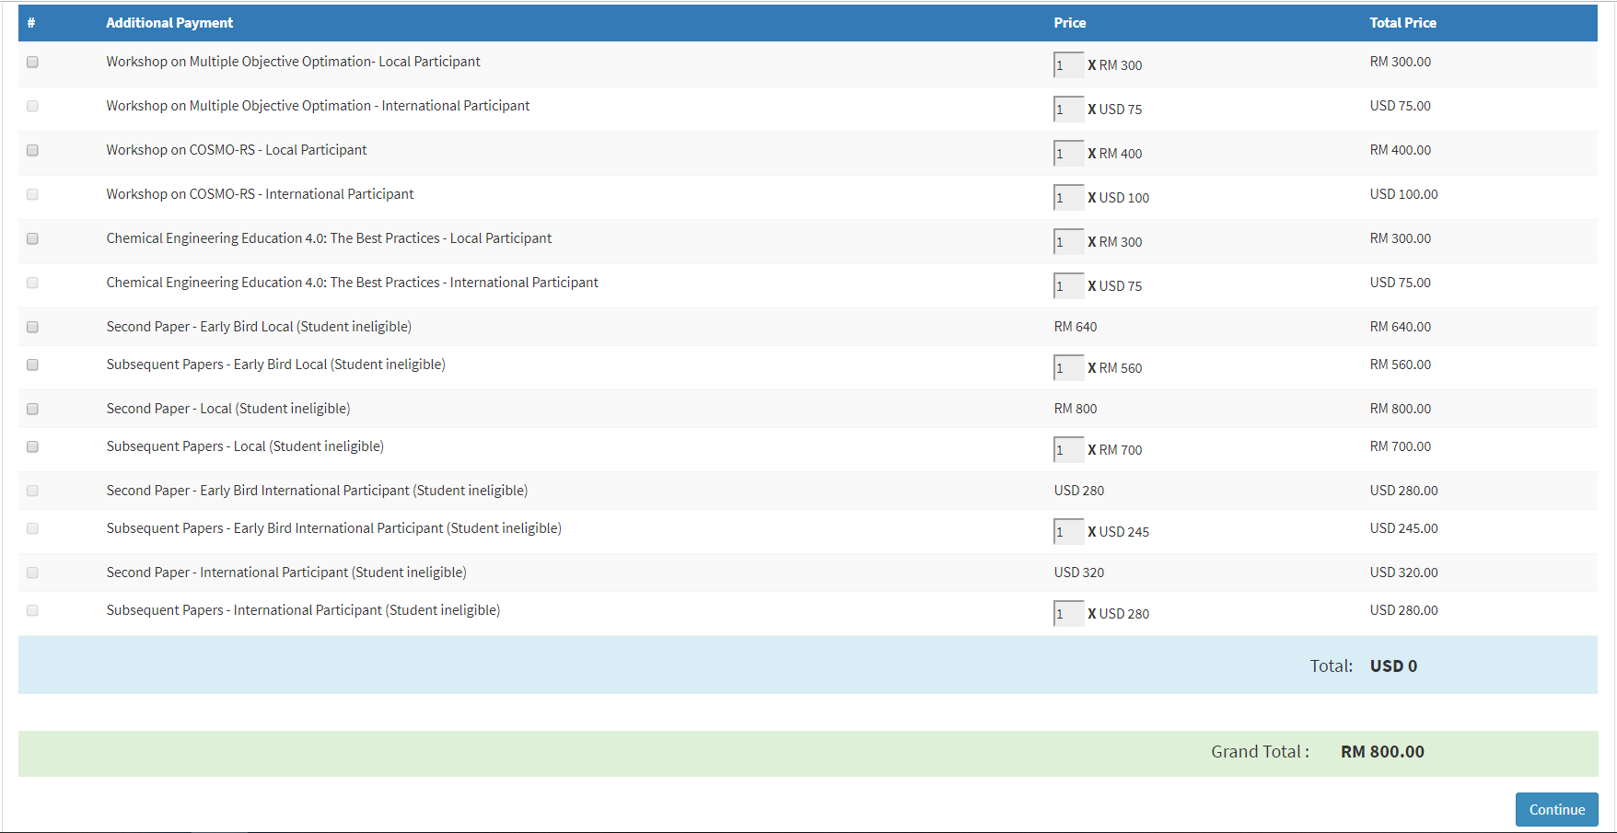

Single registration for local participant. No additional payment. Total payment due is RM800.

