EXTENDED ABSTRACT TEMPLATE
A.B. Surname¹., B. C. Surname,² C. D. Surname,^{1,2} D. Surname,¹ E. Surname,³ F. Surname⁴*
¹ Affiliation 1
² Affiliation 2
*Corresponding author: aaa@um.edu.my
(*remark - corresponding author must be the principal investigator for the project)

Madani Initiative:
Madani Core :
SDG Alignment:
Fund Total (RM):
Project Location:
Number of Beneficiaries:
Group of Beneficiaries:
Collaborators:
Project Impact:
Output & Outcome:

Extended Abstract

The abstract will enable the reviewers and the Scientific Committee to decide the suitability of the work for presentation at the conference. Authors are requested to submit the electronic form of an extended abstract via online submission. The submission details/platform will be updated soon.

The extended abstract can be written in English or Malay Language. The writing must be in MS Word format in single-spacing using 12 points of Times New Roman and formatted with justified alignment. Text paragraphs must be justified with no indentation. The length of the abstract is restricted to the maximum of FIVE (5) pages.
The extended abstract must be concise and informative, and comprised of the objective of the study, methodology, and conclusion of the work. The extended abstract can contain a maximum of THREE (3) supporting figures or images. All figures or images should be centered, and caption should be place under the figure or image (see Figure 1). Page format of the abstract should be in A4 size with a margin of 2.5 cm wide from the right, left, top and bottom, Pages should not be numbered

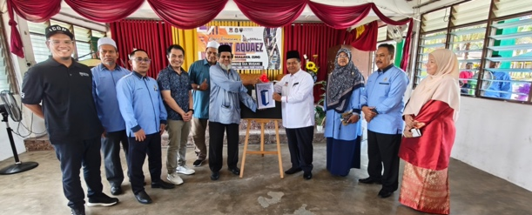

Fig. 1: Official Handover and Launching Ceremony of SMART AQUAEZ at Maahad Muhammadi, Gua Musang, Kelantan (3 May 2026).

Reference of the article should be included in the extended abstract and numbered consecutively using Arabic numerals in square brackets. The reference list should be in 12 point of Times New Roman, using the format given and justified (see Reference)
Keywords: Please provide 4 to 5 keywords separated by semicolon e.g., MADANI; InACE 2026; Industry
Acknowledgment
The author acknowledge the financial supported provided by the Universiti under MADANI initiatives.

Reference

[1] Sualman, I. (2024). The perception and understanding of Malaysia Madani’s core values. In Business Sustainability with Artificial Intelligence (AI): Challenges and Opportunities: Volume 1 (pp. 417-426). Cham: Springer Nature Switzerland.

