SMART AQUAEZ @UNIMADANI: AUTOMATED SOLAR-POWERED ULTRAFILTRATION SYSTEM FOR SUSTAINABLE CLEAN WATER SUPPLY AT MAAHAD MUHAMMADI, GUA MUSANG, KELANTAN
Junaidi, M. U. M., Rabuni, M. F.*, Hussain, M. A., Amir, Z., and Adnan, F. H.
Department of Chemical Engineering, Faculty of Engineering, Universiti Malaya, 50603 Kuala Lumpur, Malaysia.
*Corresponding Author Email: fairus.rabuni@um.edu.my

Madani Initiative: | National Program UniMADANI Grant Allocation (Kementerian Pendidikan Tinggi)
Madani Core: | Sustainability (Teras 1 - Kelestarian) and Well-being (Teras 2 - Kesejahteraan / Ihsan)
SDG Alignment: | SDG 6 (Clean Water & Sanitation) and SDG 7 (Affordable & Clean Energy)
Fund Total (RM): | 80,000.00
Project Location: | Maahad Muhammadi, Gua Musang, Kelantan, Malaysia (Completed: May 2026)
Number of Beneficiaries : | 1,000
Group of Beneficiaries: | Secondary school community of 1,000 students, teachers, and staff (including 300 boarding students)
Collaborators: | Universiti Malaya (UM), Berqat Mechanics Engineering Sdn. Bhd., Jabatan Kejuruteraan Kimia
Project Impact: | Provision of green, chemical-free clean water; operational self-reliance via localized training; reduced waterborne disease risks; over 80% savings in purchasing bottled water on-site; hands-on STEM education exposure.
Output & Outcome: | Installed off-grid 500-700 L/hr solar-powered automated ultrafiltration unit; established community-led water committee; trained operators for continuous self-maintenance; promoted local green growth.
ABSTRACT
Providing safe and reliable drinking water to remote rural educational institutions remains a persistent challenge in Malaysia due to geographical isolation, frequent municipal water supply disruptions, and high seasonal turbidity of groundwater and river sources. Under the national UniMADANI initiative, Universiti Malaya successfully deployed the SMART AQUAEZ system at Maahad Muhammadi, Gua Musang, Kelantan. This project integrates chemical engineering innovations with social sustainability principles to support approximately 1,000 students, teachers, and staff, including 300 boarding students. The SMART AQUAEZ system is an off-grid, solar-photovoltaic-powered ultrafiltration unit that produces 500-700 L/hr of high-purity, chemical-free potable water. To address the historical 'educational and technical gap' in rural communities, the project implemented a comprehensive community-empowerment program. Local operators, teachers, and students were trained in system operations and maintenance, and a localized school water management committee was formed. The system's innovative automated self-cleaning for membrane backwashing mechanism, minimizes membrane fouling, reducing maintenance overhead and ensuring long-term operational sustainability (TRL 9). Water quality analysis confirmed that the treated water meets the drinking water standards, achieving zero turbidity and complete pathogens elimination.
Keywords: SMART AQUAEZ, Solar-Powered Ultrafiltration, UniMADANI, Rural Water Supply, Sustainability, Membrane Backwashing
INTRODUCTION AND OBJECTIVES
Access to clean and safe drinking water is a fundamental human right recognized under United Nations Sustainable Development Goal 6 (SDG 6). Despite Malaysia's rapid modernization, roughly 10% of rural communities in remote areas still lack reliable access to clean water networks, relying on gravity-fed surface streams, hill rivers, or boring wells. These raw water sources are highly vulnerable to seasonal weather patterns, agricultural runoff, and high turbidity during monsoon seasons (Abeysuriya et al., 2008). The problem is particularly acute in boarding schools like Maahad Muhammadi in Gua Musang, Kelantan, which serves as a centralized hub for 1,000 students, staff, and 300 on-site boarders. Traditional water treatment systems in such settings often fail due to the 'educational and technical gap', the lack of on-site engineering expertise and low STEM awareness (Weissbrodt et al., 2020), which leads to rapid system clogging, membrane fouling, and eventual abandonment.
To address this socio-technical gap, the Department of Chemical Engineering at Universiti Malaya, led by Dr. Mohd Fairus bin Rabuni deployed the SMART AQUAEZ system under the national Program UniMADANI in May 2026. The SMART AQUAEZ represents a technology-matured (TRL 9) off-grid water purification solution. It is designed for plug-and-play operation, ensuring that non-technical users can comfortably operate and maintain it. By combining a solar-photovoltaic power source with an automated, chemical-free ultrafiltration (UF) system, the project aligns with both SDG 6 and SDG 7 (Affordable and Clean Energy), as well as the Malaysia MADANI pillars of Sustainability (Teras 1) and Well-being (Teras 2).
Objectives of the Study:
- To fabricate and install a fully automated, solar-powered SMART AQUAEZ ultrafiltration unit at Maahad Muhammadi, Gua Musang, Kelantan, with a daily capacity of delivering 500-700 L/hr of potable water.
- To implement a social sustainability framework by training local school operators, forming a self-sustaining school water management committee, and providing interactive STEM education on water health to students.
METHODOLOGY
The SMART AQUAEZ system represents a decade of rigorous engineering research, originally pioneered in 2013 by Prof. Emeritus Ir. Dr. Mohd Azlan Hussain and matured in partnership with industry collaborator Berqat Mechanics Engineering Sdn. Bhd. to reach Technology Readiness Level 9 (TRL 9). The physical configuration of the system deployed at Maahad Muhammadi consists of a robust stainless-steel skid housing a raw water intake pump, an automatic disc-filter pre-filtration stage, a main hollow-fiber ultrafiltration (UF) membrane module, a germicidal ultraviolet (UV) disinfection chamber, and 2000 litre water tanks for water storage
An innovative feature of the SMART AQUAEZ is its fully automated self-cleaning cycle. Unlike commercial reverse osmosis (RO) systems that require high operating pressures (>10 bar) and frequent chemical cleaning, ultrafiltration operates under low pressure (<2 bar). When the PLC detects a pressure drop or reaches a specific operating time interval, it automatically reverses the water flow (backwash) and introduces compressed air (air-scouring) to shake off suspended solids accumulated on the membrane surface, venting them via a drain valve (Chew et al., 2016). This automated maintenance reduces human error and chemical usage, solving the key bottleneck of system longevity in rural areas.
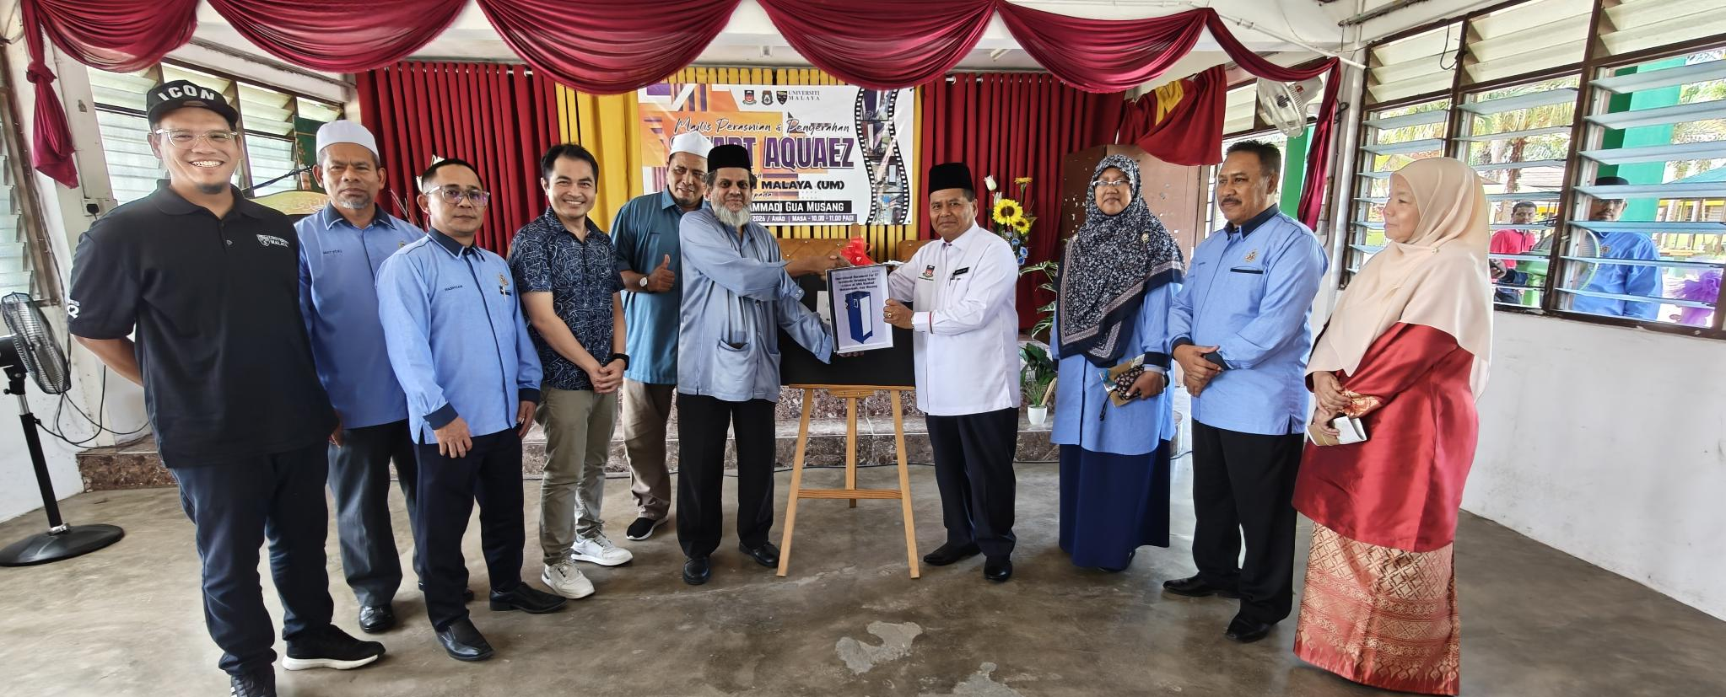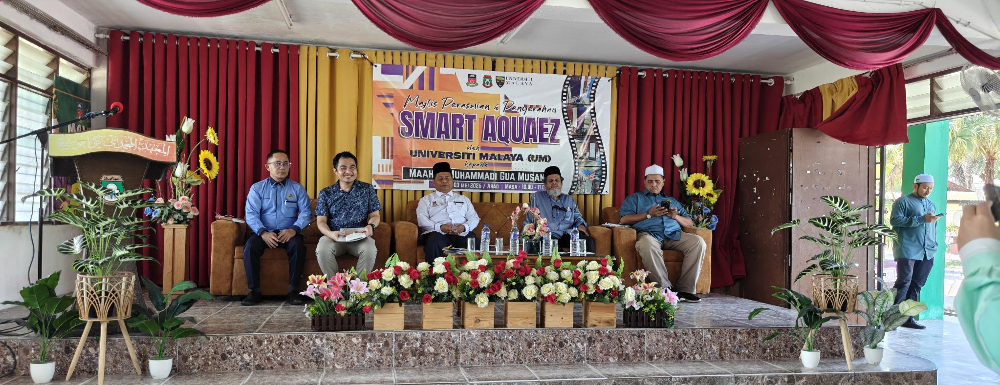
Figure 1: Official Handover and Launching Ceremony of SMART AQUAEZ at Maahad Muhammadi, Gua Musang, Kelantan (3 May 2026)

For social integration, a Quadruple Helix Model (Ehrenfeld & Hoffman, 2013) for Academia-Society-Government-Industry integration was applied. During the 12-month implementation timeline, the UM engineering team conducted hand-over training workshops. Four dedicated school staff members were trained to handle simple filter replacements and routine visual checks. Simultaneously, the 'SMART AQUA-EXCHANGE EDUCATION' STEM program was organized, allowing students to learn about membrane technology, water hygiene, and renewable energy, turning the on-site system into a live educational laboratory.

RESULTS AND DISCUSSION
The SMART AQUAEZ system was officially handed over on 3 May 2026 and achieved full operation in May 2026. The official launching ceremony brought together Universiti Malaya researchers, Maahad Muhammadi school administrators, and the local Gua Musang community, as depicted in Figure 1. This launch ceremony, attended by more than 1,000 members, established the cooperative community structure that governs the water committee.
The physically installed system, shown in Figure 2, is positioned directly next to the school's primary boarding dormitory complex. Raw well water and boring water, which routinely exhibited turbidity values exceeding 15 NTU and reddish iron discoloration, were fed into the system. Post-treatment water analysis indicated a complete elimination of physical turbidity (<0.1 NTU), zero E. coli or coliform counts, and a stabilized pH within the potable range of 6.8-7.2 (Ahmed et al., 2020). These values fully comply with the stringent drinking water standards of the Malaysian Ministry of Health (MOH).
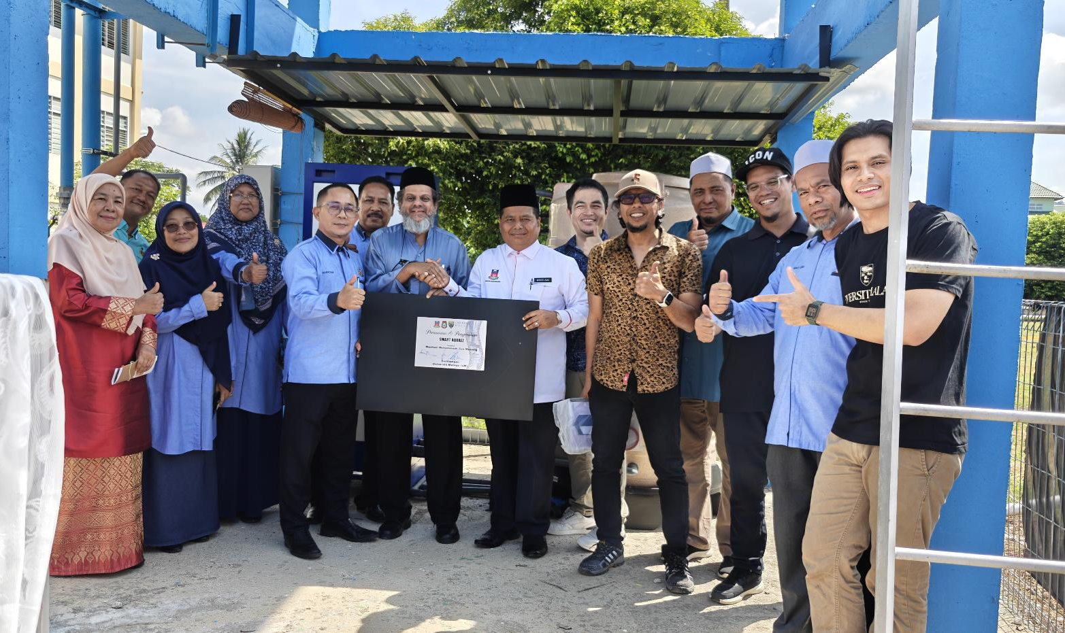
Figure 2: Deployed SMART AQUAEZ Solar-Powered Automated Ultrafiltration System in operation at Maahad Muhammadi, Gua Musang
Table 1: Technical and economic comparison between SMART AQUAEZ and alternative water solutions
Parameter | SMART AQUAEZ System | Commercial TRUNZ System | Conventional Rural Boiling/Filters
Filtration Tech | Ultrafiltration (UF) + UV | Reverse Osmosis / UF | Gravity Filter / Thermal Boiling
Production Cost / 1k L | < RM 0.20 | > RM 4.00 | High (RM 12.00 in electricity/gas)
Operating Pressure | Low (< 2.0 bar) | High (> 10.0 bar) | Atmospheric (Gravity)
Local Tech Support | Immediate (UM & Berqat) | None (Imported from Europe) | Self-reliant but low quality

Furthermore, a key focus of this study was technical-economic benchmarking. The operational cost of SMART AQUAEZ was compared against commercial imported systems such as the TRUNZ Water System, as well as conventional municipal supply and boiling. SMART AQUAEZ operates at a production cost of below RM 0.20 per 1,000 liters. This represents a reduction of over 95% in cost compared to imported commercial systems, which suffer from a lack of local spare parts and technical support, leading to prohibitive maintenance fees.
CONCLUSION AND RECOMMENDATIONS
The Program SMART AQUAEZ @UniMADANI at Maahad Muhammadi, Gua Musang, represents a highly successful model of integrating chemical engineering innovation with local social sustainability. By deploying a low-pressure, solar-powered ultrafiltration system, the project provided 1,000 school community members with 500-700 L/hr of chemical-free potable water that fully complies with Malaysian Ministry of Health standards. The socio-technical gap was successfully addressed through local operator workshops and student STEM programs, ensuring that the technology remains operational and trusted over the long term without external reliance. For future directions, it is highly recommended to expand this localized management model to other remote schools in East Malaysia and Kelantan. Furthermore, ongoing research is focusing on downsizing the system into a 'Mini SMART AQUAEZ' unit for small villagers dwellings (less than 50 people) and integrating advanced solar-evaporation (Solar EVAP) modules to treat highly mineralized borehole water and floodwater during monsoons.
REFERENCES
Ahmed, M. F., Mokhtar, M. B., Alam, L., Mohamed, C. A. R., & Ta, G. C. (2020). Investigating the status of cadmium, chromium and lead in the drinking water supply chain to ensure drinking water quality in Malaysia. Water, 12(10), 2653.
Abeysuriya, K., Mitchell, C., & Willetts, J. (2008). Expanding economic perspectives for sustainability in urban water and sanitation. Development, 51(1), 23-29.
Chew, C. M., Aroua, M. K., Hussain, M. A., & Ismail, W. M. Z. W. (2016). Evaluation of ultrafiltration and conventional water treatment systems for sustainable development: an industrial scale case study. Journal of Cleaner Production, 112, 3152-3163.
Ehrenfeld, J. R., & Hoffman, A. J. (2013). Flourishing: A frank conversation about sustainability. Stanford, CA: Stanford University Press.
Weissbrodt, D. G., Winkler, M. K., & Wells, G. F. (2020). Responsible science, engineering and education for water resource recovery and circularity. Environmental Science: Water Research & Technology, 6(8), 1952-1966.

