TEMPLATE OF EXTENDED ABSTRACT

EXTENDED ABSTRACT

TITLE OF YOUR RESEARCH

Author One^{a*}, Author Twoª, and Author Three^{b}

ª Department of XXXXXX
Universiti XXXXX, Kuala Lumpur, Malaysia

^{b} Department of XXXXXX
Universiti XXXXXX, Johor, Malaysia

*E-mail: XXXX@XXXX.XXX.XX

Abstract
The abstract should be written with font size of 10 pts, Arial, single line spacing. Summarize your research by stating research objectives, research gap, methodology, findings and contribution, contained within one paragraph (between 200 and 250 words).
Keywords: Maximum 5 words separated by semicolon and justified with font size of 10 pts.

Introduction
The introduction section should (1) introduce and provide a background of the study; (2) briefly review the pertinent literature; (3) present research problems; (4) research scope, research question and objective.

Methodology
The methodology must be clearly stated and described in sufficient detail or with sufficient references. The author shall explain the research questions, describe the research framework, and the methods - qualitative or quantitative - sampling, location and procedures applied in detail. Explain why the chosen method(s) are suited to address the research problem.

Results
Presentation of the result obtained. If possible, use descriptive figures or tables rather than explain in text. Do not discuss or interpret the results at this stage.

Following is an example for table:

Table 1: Important Dates of UMACE 2021
Date | Activity
7 July 2021 | Extended abstract submission
8 August 2021 | Extended abstract submission deadline
31 August 2021 | Notification of extended abstract acceptance
14 September 2021 | UMACE 2021

Following is an example for figure:

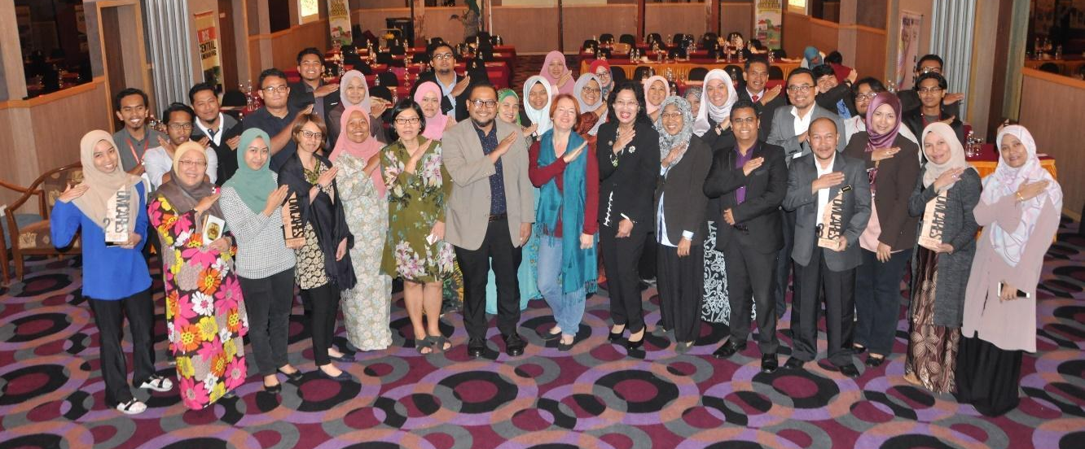

Figure 1: UMACE 2019 is an international conference that aim to gather multi-
stakeholders involved directly or indirectly in community engagement projects.

Discussion
Discuss the results in perspective by comparing to past studies or generally accepted knowledge in the field. Criticise your own method and results, for example, with respect to the simplifications made.

Contribution
State contribution of the research towards the beneficiaries that is directly or indirectly related - theoretically and/or practically.

Impact (Behavioural, Awareness / Social-education, human rights / Health and Wellbeing / Technological/ Legal & Political /Economy & Finance /Culture / Environment, etc.)
Researchers can explain any type of impact mentioned in parentheses above.

Conclusion
Conclusions should include (1) the principles and generalizations inferred from the results, (2) any exceptions, problems or limitations of the work; and (3) conclusions drawn and recommendations.

Acknowledgement
The authors are thankful to xxx for their contribution on xxx for this work. This study was financially supported by Universiti Malaya Grant xxx (Grant No.) or Ministry xxxxx Grant, managed by xxx, xxx.

References

Vogels, A. G. C., Crone, M. R., Hoekstra, F., & Reijneveld, S. A. (2009). Comparing three
short questionnaires to detect psychosocial dysfunction among primary school children: a randomized method. BMC Public Health, 9, 489. https://doi.org/10.1186/1471-2458-9-489

Payne, S. (1999). 'Dangerous and different': Reconstructions of madness in the 1990s and
the role of mental health policy. In S. Watson & L. Doyal (Eds.), Engendering social policy (pp. 180-195). Open University Press.

Reid, S. F. (2016). The importance of scientific method [Unpublished manuscript], BSC100:
Building Blocks for Science Students, Murdoch University.

Matthews, J. (1999). The art of childhood and adolescence: The construction of meaning.
Falmer Press.

