Full Paper Title in Title Case (Font: Arial 16 bold)

First Author Smith^{1,a}, Second Author Smith^{1,b} and Third Author Smith^{2,c}
¹ Address of the first author, including affiliation
² Address of the second author, including affiliation
(use Arial 10 typeface for author’s Affiliation)
Email: ª xxxx@xxx.xx, ^{b} xxxx@xxx.xx, ^{c} xxxx@xxx.xx

ABSTRACT

An abstract is a single paragraph, without subheadings, indentation, bullets or references. It should be an explicit summary that states the problem, the objectives, the methods used, and the major results and conclusions. It should be 1.15-spaced in 11-point Arial. Do not include bullets/lists or references in the abstract. Use only the SI units. Use a negative exponent (e.g. kgm⁻³) and do not indicate units as divisions (e.g. kg/m3). Chemical formulae should be written in a standard form such as “CaCO₃”, not “CaCO3”. Use a zero before decimal points such as “0.45,” not “.45.” The first part of your abstract should state the problem or issue you set out to solve and explain your rationale for pursuing the research. Your study aims to solve this problem and/or add to your discipline’s understanding of the issue. Your abstract should also describe the research methods. Next, your abstract should indicate the results or outcomes of your work so far. Finally, your abstract should close with a statement of the project’s implications and contributions to its field. The content of the abstract will be the basis for acceptance of the paper presentation at the international research conference. The abstracts will be peer-reviewed, and authors will be informed about acceptance for presentation via email. Be sure to adhere to the word limitation for the abstract (175 - 250 words). The abstract should be submitted in the format of MS Word (.doc or .docx) document. Keywords should be given leaving a one-line space below this text.

Keywords: Maximum 5 keywords arranged according to alphabets and separated by semicolon; and justified with font size of 10 pts.

1. INTRODUCTION
It is expected that authors will submit carefully written and proofread material. Spelling and grammatical errors and language usage problems are not acceptable in the final submission. The full paper should be within 6 - 10 pages, with the reference starting at the 6th page (minimum) and the paper length should not exceed 5000 words.
Papers should clearly describe the subject's background, the author's work, the methods used, and a concluding discussion on the importance of the work. Papers are to be prepared in English (British or American). Technical terms should be explained. Acronyms should be written out at their first appearance.

2. SUBMITTING THE PAPER
The full paper must be submitted electronically on the conference portal at https://umevent.um.edu.my/ICSAM2024. The paper should be submitted by 25th October 2024. Any inquiries related to the submission can be emailed to icsam@um.edu.my.

3. PAPER FORMAT
The uniform outlook will help the reader to follow the manuscript. This can be obtained most easily if authors use this template file to construct their papers. Please note the following details: this template is an A4 format. All text paragraphs should be 1.15-spaced, with the first line indented by 10 mm (0.4 inch). Double spacing should only be used before and after headings and subheadings as shown in this example. The position and style of headings and subheadings should follow this example. No spaces should be placed between paragraphs. Please do not change any of the above-mentioned page, paragraph and font settings.

3.1. Fonts
Papers should use 11-point Arial font. The styles available are bold, italic and underlined. It is recommended that text in figures is not smaller than a 10-point font size.

3.2. Tables and Figures
Figure captions and table headings should be sufficient to explain the figure or table without having to refer to the text. Figures and tables presented must be cited in the text before being presented. Styles Heading Table and Caption Figure are available in this template for tables and figures. The following is the example for Table 1.
Table 1: Title of Example Table
Specimen | Carbon (wt%) |  |  |  | Oxygen (wt%)
Specimen | Uniform | ELF | SRSS | error | Uniform | ELF | SRSS | error
Control sample | 0.22 | 0.50 | 0.35 | 9% | 12.58 | 0.69 | 0.60 | 3%
Mixture with PVA | 0.55 | 0.70 | 0.39 | 6% | 11.35 | 0.55 | 0.54 | 6%
Tables and figures should be placed close after their first reference in the text. All figures and tables should be numbered with Arabic numerals. Table headings should be above the tables. Figure captions should be centred below the figures. Minimum figures’ resolution: 150dpi. Please make sure that any coloured figures are equally comprehensible in black and white.

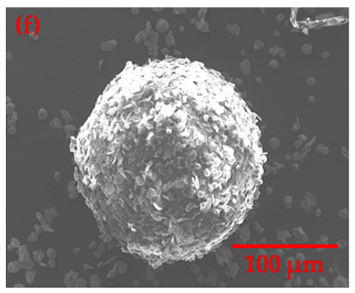
Fig. 1: SEM of powder. A figure caption is always placed below the illustration. Short captions are centered, while long captions are justified.
3.3 Equations
Displayed equations are centered and set on a separate line.
x + y = z (1)

REFERENCES
The list of references must follow the A.P.A. style.
For more information, please visit: http://www.apastyle.org/index.aspx

Corresponding author

