Manuscript Title. use “title” style. the title length should not exceed 20 words
A. A. Name¹, A. A. Name^{2,*}, …… (Use “Author’s Names” style)
¹ Department of XXXXX, Faculty of XXXXXX, University XXXXX, City Postcode, Country (Use “Affiliation” style)
*Corresponding author:

Abstract (for first heading, use “Heading 1” style)
Your abstract should include a background, research gap or problem, proposed solution and most significant results with conclusion. The abstract length should not exceed 250 words. (Use “Text Body” style).
Keywords (use “Keywords” style)
Add 3-5 keywords Keyword 1; Keyword 2; Keyword 3.

Heading 1
Your text here using “Text Body”

Heading 2 (use “Level 2” numbering)
For figures, use high-quality figures (300 dpi). Set the figure from Format Wrap Text In-line with text. Figure caption use “Caption” style. Make sure every figure is cited in the text.
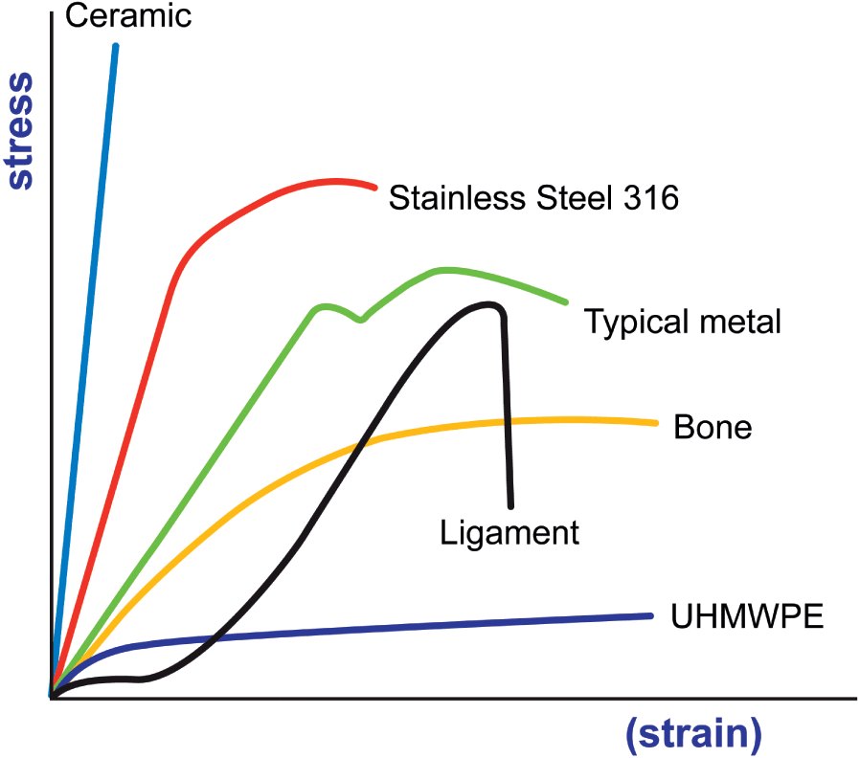
Figure 1: Stress-strain curve for different engineering materials

Table 1: XXXXXXXXXX (“Caption” style)
Sample | Sample 1 | Sample 2
Parameter | xxxx | Xxxxx
Value
For reference style, use IEEE referencing style.

