<EXTENDED ABSTRACT TITLE IN TIMES NEW ROMAN 14PT,
UPPER CASE, BOLD AND CENTRED>
A.B. Corresponding Author¹ and C.D. Other²

¹Affiliation
²Affiliation
¹ aspdevent@um.edu.my [Email of corresponding author only]

KEYWORDS
[Text goes here: Suggest up to 5 keywords, separated by commas.]

[Main text starts here This document represents the template for an extended abstract for Spark & Share Rapid Talks session, UM MINT 2026. We request that authors submit an extended abstract of between 500 and 600 words (excluding references).

Suggested structure includes:

- Background/ Context
- Issue or Challenge
- Approach/Innovation/Practice
- Implementation
- Impact/ reflection/ key lessons learned
- Key message to participants

For consistency, we ask that authors use the following style when preparing the extended abstracts.

- Font. Please use Times New Roman font with single spacing between lines. The recommended font size is 14 points for the paper title and 12 points elsewhere. The main text should be justified on both sides.

- Heading Styles (where applicable)

FIRST LEVEL HEADING STYLE

Second level heading style

Third level heading style

- Bulleted List Style. This is a bulleted ordered list

- Times New Roman, 12 points
- Left aligned, single-spaced
- No indents except a hanging indent 1cm [Bulleted List Style]

- Ordered List Style. This is an ordered list

- Times New Roman, 12 points
- Left aligned, single-spaced
- No indents except a hanging indent 1cm. Indentation may be varied slightly to improve the fit.
- select only from these kinds of ordering: 1., 2., …; i., ii., …; a., b., … Do not use any other kind. [Ordered List Style]

- Figures and Tables. Tables and Figures should be numbered and captioned.]

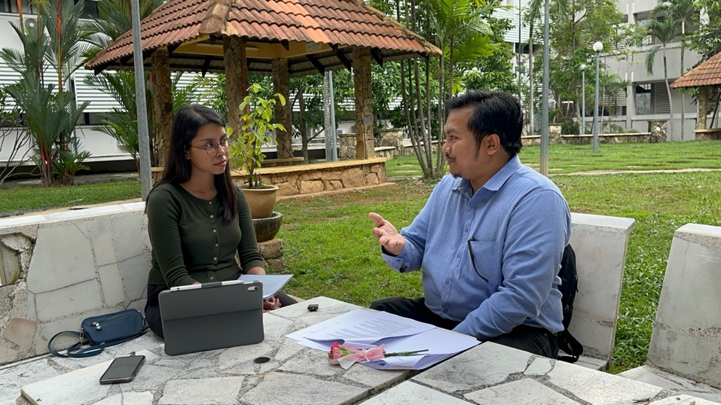
Figure 1. Sample of a figure (legend is below figure) [Figure Style]

Figures must be placed in their correct location in your running text. All figures should be included in your Word file, and not in separate graphic or drawing package format. Labelling should be consistent with the fonts used in the text of your paper, i.e., Times New Roman. Number sequentially, Figure 1, Figure 2, etc. Do not use variations such as Figure 1a, 1b.

Table 1
A sample table (title is above table, left aligned) [Table Title Style]
Location [Paper Body style] | Tables must be placed in their correct, appropriate locations in your running text [Paper Body Style]
General | In general use Times New Roman 10 point and other body text specifications for all text within a table and its title, though 9 point may be used as required for narrow columns. Tables should have a title with consecutive numbering (e.g.: Table 1: Title of the table), bolded, using sentence case, centred, and located at the top of the table. For headings within tables use sentence case, with bold and centering optional.
Format | Centre each table and select appropriate widths for the table and for each column, using percentages. Use of borders for all cells ('All', with style '1/4 point') is recommended, mainly because borders seem to be helpful for on screen reading. In columns of numbers, use centre or decimal point alignment.
Explanatory text | If your table requires explanatory text that is inappropriate for placing in your running text, place it at the bottom of the table, formatted to the same width as the table.
Other features | Cell background colouring or shading may be used, but check that grey scale printing (600 dpi) is not impaired, and note that when a web version file is created, the Proceedings editors may use a standard background colour for the first row or other elements of a table.
Main text ends here]

REFERENCES
Please use the APA citation format. In the text, please cite in the author- year format, e.g. (Author, 2021) or (Author1 & Author2, 2022) or (Author1 et al., 2023). The references should be placed at the end of the abstract in alphabetical order.

